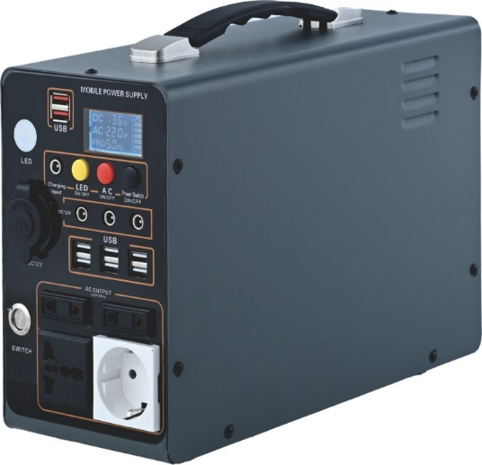

Model No : SJ-Y-600

Inverter : Rated power 500 ; peak power 660w (12v system )

Battery capacity: 307WH/460WH/600WH (Optional)

Battery Type: Lithium iron phosphate battery

(Built-in overcharger, low voltage, overtemperature battery protection plate)

AC Output: AC220V/50Hz ,European socket *2pcs ; Universal socket* 2pcs.

DC Output: DC 12V/10A socket *1pcs ;DC12V/ 3A socket * 3pcs

USB output : DC5V/2A port* 8pcs;

LCD display screen: AC/ DC voltage ,Frequency ,LED light (lighting and SOS ), Percentage of electricity display.

Heat dissipation system: Automatic start of overtemperature fan, convective rapid heat dissipation.

Charging mode: AC 220V/5A adapter ,solar panel DC18V/100W/5A (Optional), charging full times 4-6 hours

Applicable scenario: Outdoor activities, Family emergency ,Boat

Applicable scope: Lighting , Fan , notebook ,car refrigerator, audio, projector ,electric drill ,drone ,mobile phone ,juicer ,coffee maker, meat grinder ,samll oxygen machine

Shell color: Black and White (customizable)

Product size: 320x150x260mm

Packing size: 410x210x290mm

Per/Box:

Weight: G.W N.W:

Loading : 20GP/40HQ

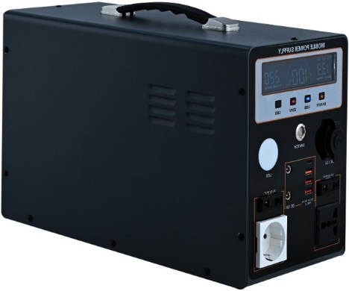

Model No: SJ-Y-1000

Inverter : Rated power 1000w ; peak power 1200w (12v system )

Battery capacity: 768WH/1024WH (Optional)

Battery Type: Lithium iron phosphate battery

(Built-in overcharger, low voltage, overtemperature battery protection plate), Power-off master switch.

AC Output: AC220V/50Hz ,European socket *2pcs ; Universal socket* 2pcs.

DC Output: DC 12V/5A socket *2pcs ;DC12V/ 10A socket * 1pcs

USB and Type-C output : DC5V/3A port* 3pcs; PD fast charging *1pcs

Control button: master switch ,USB LED, AC220V control button

LCD display : battery display, charging icon display, USB output display, AC220V start display, fault icon display, charge and discharge fault code display, LED lamp display, AC output power display, input power display, fan operation display, Bluetooth switch display, high and low temperature detection display, overvoltage and undervoltage alarm, overcurrent short circuit alarm

Inverter :overloading ,overtemperature ,overvoltage and short circuit protection .

Heat dissipation system: Automatic start of overtemperature fan

Charging mode: AC 220V/5A adapter ,solar panel DC18V/100W/10A ,One string of two merges ( Optional), charging full times 4-6 hours

Applicable scenario: Outdoor activities, Family emergency ,Boat

Applicable scope: Lighting, Fan, TV, refrigerator, washing machine ,audio, projector ,electric drill ,drone ,notebook ,mobile phone ,juicer ,coffee maker, meat grinder ,dehumidifier

Shell color: Black and White (customizable)

Product size: 380x170x270mm

Packing size: 450x205x310mm

Per/Box: 1 pcs

Weight: G.W 12kg N.W:11kg

Loading : 20GP/40HQ 980pcs/2100pcs

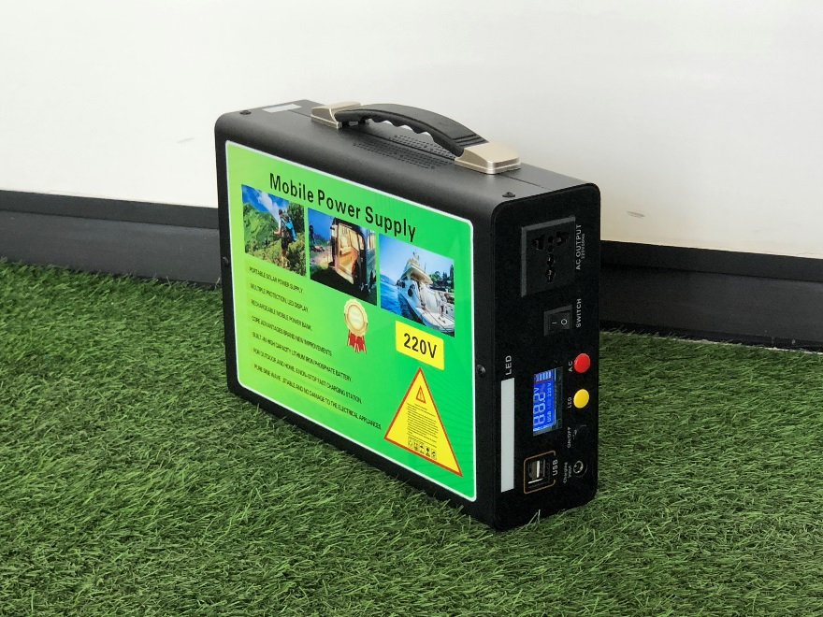

SJ-T-280

Rated power: 300W, peak 350W 12V

Battery charge: 192WH/300WH

Battery type: lithium iron phosphate (overcharge, overdischarge, overtemperature protection)

DC output: USB two ports. 1 LED lamp

LCD display screen: battery voltage, power display, AC220V, frequency, function key control display

Heat dissipation system: boot self-start

Charging mode: AC220V adapter 3A, polycrystalline solar panel DC18V/50W,3A/H (optional) (3-5 hours full)

Applicable scenarios: outdoor activities

Scope of application: 70W fan, 70W laptop, 65W car refrigerator, 30W outdoor audio, 100W projector, 345W electric drill,

Drone battery, tablet computer, mobile phone, ventilator 40W, small oxygen machine 120W

Product color: black, white optional

Packing size: 390x95x230mm

Product size: 280x70x200mm

Gross weight: 2.6 kg net weight: 2.1 kg

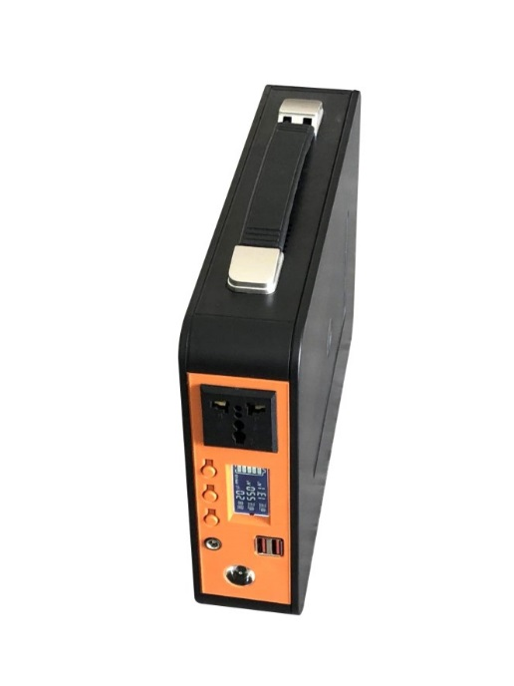

SJ-H-300

Rated power: 300W, peak 350W 12V

Battery charge: 192WH/300WH

Battery type: lithium iron phosphate (overcharge, overdischarge, overtemperature protection)

DC output: dual USB

LCD display screen: battery voltage, power display, AC220V, frequency, function key control display

Heat dissipation system: boot self-start

Charging mode: AC220V adapter 3A, polycrystalline solar panel DC18V/50W,3A/H (optional) (3-5 hours full)

Applicable scenarios: outdoor activities

Scope of application: 70W fan, 70W laptop, 65W car refrigerator, 30W outdoor audio, 100W projector, 345W electric drill, UAV battery.

Tablet computer, mobile phone, ventilator 40W, small oxygen maker 120W

Shell color: ABS plastic, orange and black (customizable 500PCS)

Product size: 300*225*65mm

Packing size: 710*480*390mm

Number of cases packed: 10 PCS

Gross weight: 25 kg net weight: 23 kg

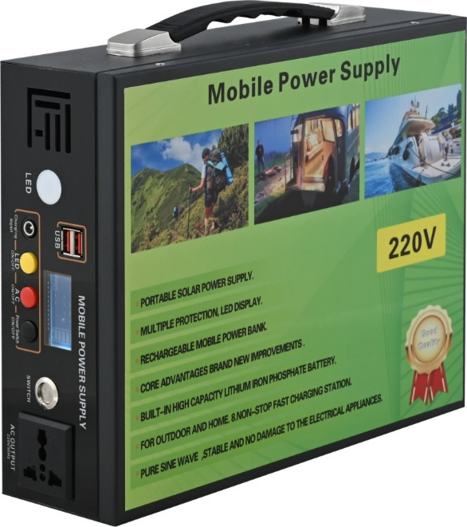

Model No : SJ-T-300

Inverter : Rated power 300 ; peak power 350w (12v system )

Battery capacity: 230WH/300WH (Optional)

Battery Type: Lithium iron phosphate battery

(Built-in overcharger, low voltage, overtemperature battery protection plate)

AC Output: AC220V/50Hz , Universal socket* 1 pcs.

DC Output: DC 12V/10A socket *1pcs

USB output : DC5V/3A port* 2pcs;

LCD display screen: AC/ DC ,LED light (lighting and SOS )

Heat dissipation system: Automatic start of overtemperature fan, convective rapid heat dissipation.

Charging mode: AC 220V/3A adapter ,solar panel DC18V/50W/3A (Optional), charging full times 3-5 hours

Applicable scenario: Outdoor activities, Family emergency

Applicable scope: Lighting , Fan , notebook ,car refrigerator, audio, projector ,electric drill ,drone ,mobile phone ,juicer ,coffee maker, meat grinder ,samll oxygen machine

Shell color: Black and White (customizable)

Product size: 300X265X85 mm

Packing size: 610X340X280 mm

Per/Box: 5pcs/CTN

Weight: G.W 23kg N.W: 21kg

Loading : 20GP/40HQ 2400/5150pcs

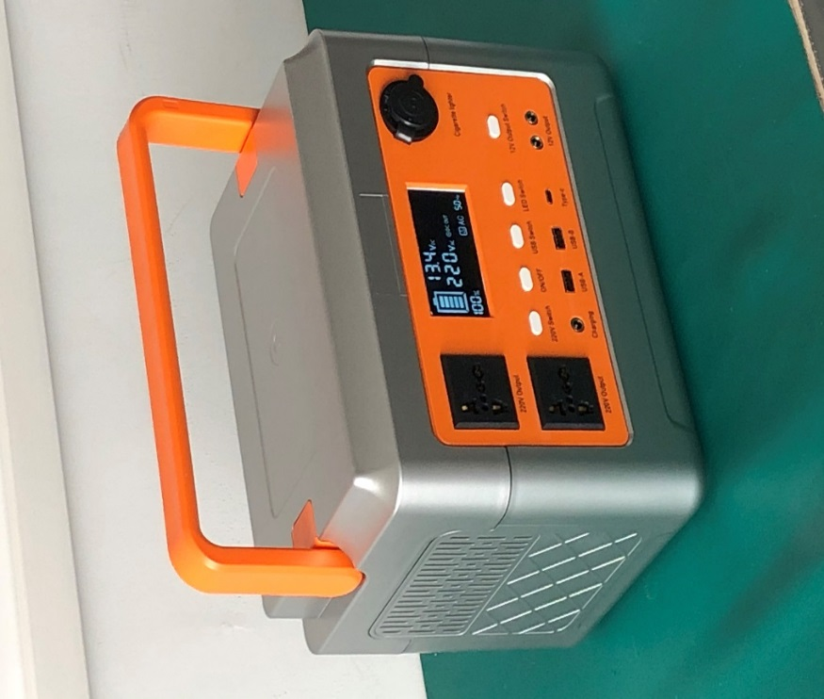

SJ-H-500

Rated power: 500W, peak 670W 12V

Battery charge: 384WH/576WH

Battery type: lithium iron phosphate (overcharge, overdischarge, overtemperature protection)

Ac output: 2 AC220V universal sockets

DC output: USB port output DC5/V/3A Type-c fast charge 5A

LCD display: AC220V start, 50Hz, battery voltage, power, LED lamp, USB,DC12V, output power display

Heat dissipation system: intelligent temperature control

Charging mode: AC220V/5A adapter, solar panel DC18V/100W/5A (optional), full charge time 4-6 hours.

Applicable scenarios: outdoor activities, family emergency

Scope of application: 70W fan, 70W laptop, 65W car refrigerator, 30W outdoor audio, 100W projector, 345W electric drill, UAV battery.

Tablet computer, mobile phone, ventilator 40W, small oxygen maker 120W

Shell color: orange plus silver gray (customizable 500PCS)

Product size: 290*200*225mm

Packing size: 380*260*285mm

Number of cases packed: 1 PCS

Gross weight: kg net weight: kg

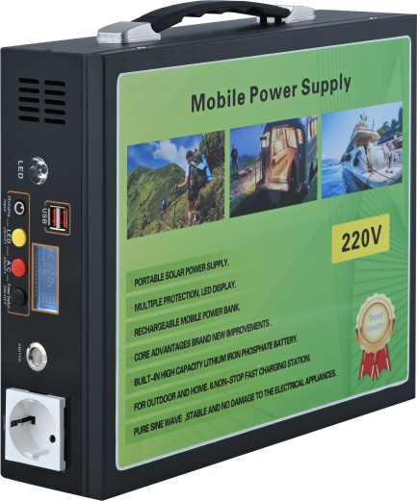

**SJ-T-500**

Inverter power: 500W (sine wave) peak power 660W 12V system

Battery charge: 269WH/384WH/504WH (optional).

Battery type: lithium iron phosphate battery (overcharge, overdischarge, overtemperature protection), front power off master switch

Ac output: AC220V/50HZ, 1 universal socket

DC output: DC12V/10A*1, USB output: DC5V/3A*2

LCD display: (AC,DC,Hz) LED lamp (always on, SOS), battery percentage display

Heat dissipation system: self-start of temperature control, rapid heat dissipation of air flow in air duct

Entertainment equipment: Bluetooth audio (optional, plus 80 yuan)

Charging method: AC220V adapter 5A, solar panel: polycrystalline DC18V/100W,5A/H (optional) (4-6 hours full)

Inverter protection: overvoltage, reverse connection, short circuit, overload, overtemperature protection function

Applicable scenarios: outdoor activities, family emergency, marine use

Scope of application: 70W fan, 70W laptop, 65W car refrigerator, 30W outdoor audio, 100W projector, 345W electric drill.

Drone battery, tablet computer, mobile phone, ventilator 40W, small oxygen machine 120W

Shell color: black, white (customizable 500PCS)

Product size: 325x90x295mm

Packing size: 390x125x320mm

Number of boxes: 5 PCS

Gross weight: 32.5kg net weight: 31 kg

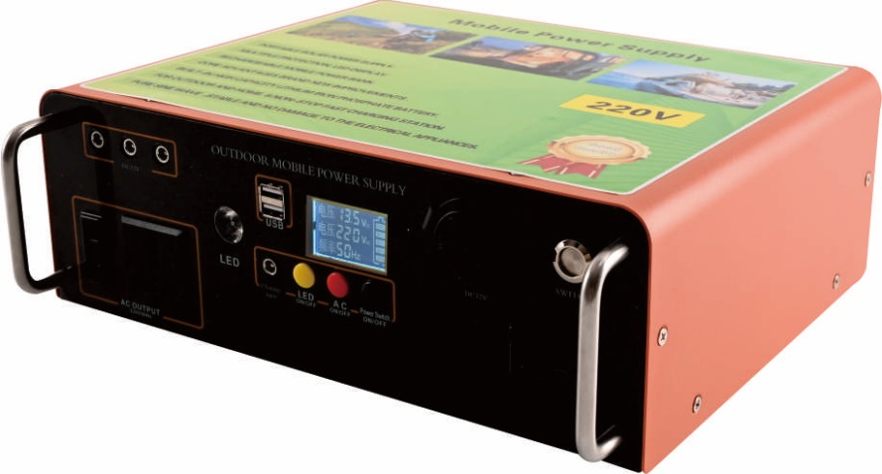

**SJ-W-500**

Inverter power: 500W (sine wave) peak power 660W 12V system

Battery charge: 384WH/500WH (optional).

Battery type: lithium iron phosphate (overcharge, overdischarge, overtemperature protection), front power off master switch

Ac output: AC220V/50HZ, 1 universal plug, 1 European plug

DC output: DC12V/10A*1, USB output: DC5V/2A*2,DC12V round insert 3

LCD display: (AC,DC,Hz) LED lamp (always on, SOS), battery percentage display

Heat dissipation system: self-start of temperature control, rapid heat dissipation of air flow in air duct

Charging mode: AC220V/5A adapter, solar panel DC18V/100W/5A (optional), full charge time 4-6 hours.

Inverter protection: overvoltage and undervoltage, reverse connection, short circuit, overload, overtemperature protection function

Applicable scenarios: outdoor activities, family emergency, marine use

Scope of application: 70W fan, 70W laptop, 65W car refrigerator, 30W outdoor audio, 100W projector, 345W electric drill, UAV battery.

Tablet computer, mobile phone, ventilator 40W, small oxygen maker 120W

Shell color: black, white (customizable 500PCS)

Product size: 335x125x295mm

Packing size: 365x150x340mm

Number of boxes: 1PCS

Gross weight: 7.3kg net weight: 7k

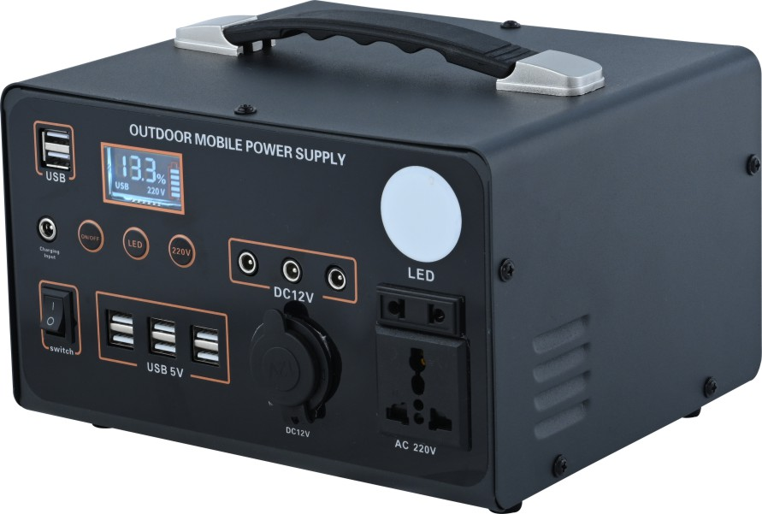

SJ-X-300

Inverter power: 300W (correction wave) peak power: 350w 12V system

Battery charge: 154WH/230WH/300WH (optional)

Battery type: lithium iron phosphate battery (overcharge, overdischarge, overtemperature protection)

Ac output: 220V/50HZ, 1 European socket, 1 universal plug

DC output: 12v / 10A*1, USB output: 5v/2A*6

LCD display screen: (AC,DC, main switch) 1 LED light (always on, SOS)

Heat dissipation system: self-start of temperature control, rapid heat dissipation of air flow in air duct

Inverter protection: overvoltage and undervoltage, reverse connection, short circuit, overload, overtemperature protection function

Applicable scenarios: outdoor activities, family emergency

Scope of application: 70W fan, 70W laptop, 65W car refrigerator, 30W outdoor audio, 100W projector, 345W electric drill, UAV battery.

Tablet computer, mobile phone, ventilator 40W, small oxygen maker 120W

Shell color: black, white (customizable 500PCS)

Product size: 280x70x200mm

Product size: 230x195x165mm

Number of boxes: 6 PCS

Gross weight: 22.5kg net weight: 21 kg

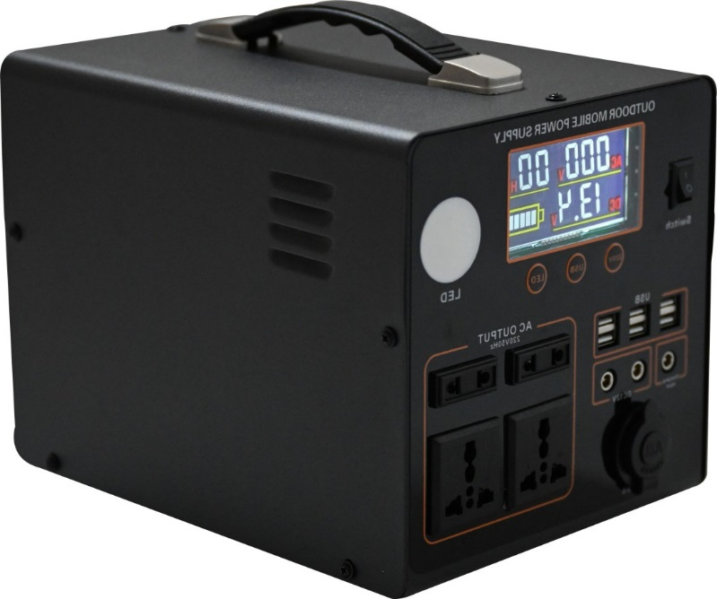

SJ-X-500

Inverter power: 500W (correction wave) peak power 660W 12V system

Battery charge: 384WH/504WH (optional).

Battery type: lithium iron phosphate battery

Ac output: AC220V/50HZ, 2 universal sockets, 2 European sockets

DC output: DC12V/5A*2, USB output: DC5V/2A*6pcs

LCD display: (AC,DC,Hz) LED lamp (always on, SOS), battery percentage display

Heat dissipation system: temperature control self-start, fast heat dissipation

Charging mode: AC220V/5A adapter, solar panel DC18V/100W/5A (optional), full charge time 4-6 hours.

Inverter protection: overvoltage and undervoltage, reverse connection, short circuit, overload, overtemperature protection function

Applicable scenarios: outdoor activities, family emergency, fishing boat electricity

Scope of application: 70W fan, 70W laptop 70W car refrigerator 65W, outdoor audio 30W, projector 100W, electric drill 345W, UAV battery, tablet computer, mobile phone, ventilator 40W, small oxygen machine 120W

Shell color: black, white (customizable 500PCS)

Product size: 265x195x230mm

Packing size: 305x235x260mm

Number of boxes: 1 PCS

Gross weight: 7.2 kg net weight: 6.8 kg

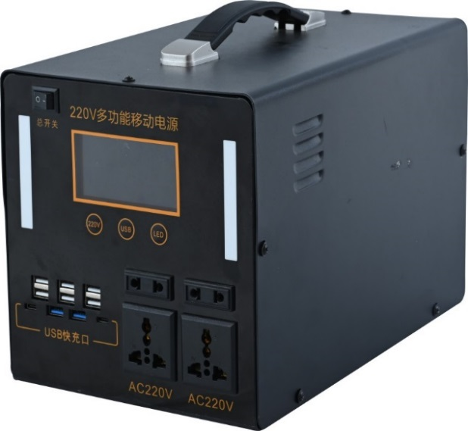

SJ-X-1000

Rated power: 1000W (correction wave) peak power: 1200W 12V system

Battery capacity: 750WH/1000WH

Battery type: lithium iron phosphate battery

Ac output: AC220V/50HZ, 2 sockets, 2 universal sockets

DC output: DC12V/10A*2, 1 car charge, USB + C port output: DC5V/2A*6,DC5C3A*4

LCD display: ON/OFF, USB, AC/DC voltage display, LED (always on, SOS), power display, margin percentage display, charging display

Heat dissipation system: temperature control self-start, fast heat dissipation

Charging mode: AC220V/5A adapter, solar panel DC18V/100W/5A (optional), full charge time 4-6 hours.

Inverter protection: overvoltage and undervoltage, reverse connection, short circuit, overload, overtemperature protection function

Applicable scenarios: outdoor activities, family emergency, fishing boat electricity

Scope of application: 50-inch TV 110W, juicer 150W, household printer 400W, motor 275W, dehumidifier 200W, household refrigerator 90-200W

Shell color: black, white (customizable 500PCS)

Product size: 295x195x230mm

Packing size: 325x225x260mm

Packing size: 390x125x320mm

Number of boxes: 1 PCS

Gross weight: 12kg net weight: 11.5 kg