家庭储能系列:

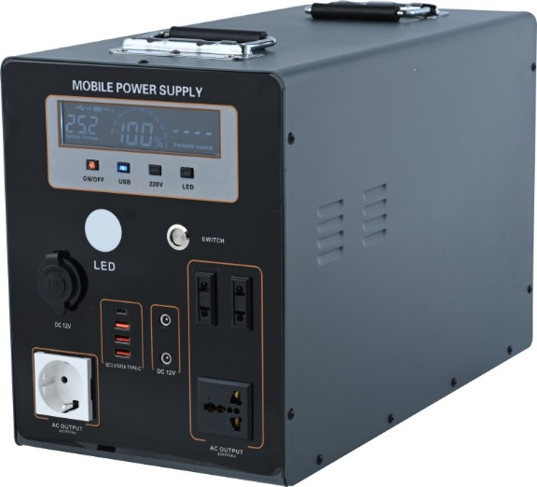

**Model No: SJ-Y-2000**

Inverter : Rated power 2000w ; peak power 2200w (24v system )

Battery capacity: 1500WH/2000WH (Optional)

Battery Type: Lithium iron phosphate battery

(Built-in overcharger, low voltage, overtemperature battery protection plate), Power-off master switch.

AC Output: AC220V/50Hz ,European socket *2pcs ; Universal socket* 2pcs.

DC Output: DC 12V/5A socket *2pcs ;DC12V/ 10A socket * 1pcs

USB and Type-C output : DC5V/3A port* 3pcs; PD fast charging *1pcs

Control button: master switch ,USB LED, AC220V control button

LCD display : battery display, charging icon display, USB output display, AC220V start display, fault icon display, charge and discharge fault code display, LED lamp display, AC output power display, input power display, fan operation display, Bluetooth switch display, high and low temperature detection display, overvoltage and undervoltage alarm, overcurrent short circuit alarm

Inverter :overloading ,overtemperature ,overvoltage and short circuit protection .

Heat dissipation system: Automatic start of overtemperature fan

Charging mode: AC 220V/10A adapter ,solar panel DC36V/100W/10A ,One string of two merges ( Optional), charging full times 4-6 hours

Applicable scenario: Outdoor activities, Family emergency ,Boat

Applicable scope: Cutting machine 1100W, high pressure water gun 1200W, impact drill 1080W, air pump 800-1500W, kettle 1000W, microwave

Furnace 1300W, electric casserole 1500W, electric vehicle 1050W, electric oven 1650W, car washer 1000-2000Lighting, Fan, TV, refrigerator, washing machine ,coffee maker, rice cooker ,blender

Shell color: Black and White (customizable)

Product size: 455x220x300 mm

Packing size: 520x240x340 mm

Per/Box: 1 pcs

Weight: G.W 20kg N.W:19kg

Loading : 20GP/40HQ 660pcs/1400pcs

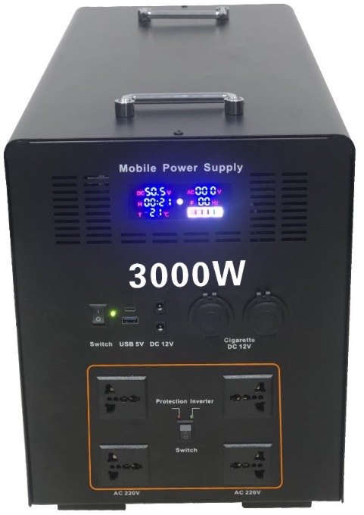

SJ-M-3000

Inverter power: 3000W (pure sine wave, high frequency) peak power: 3300W 24ram 48V system

Battery charge: 3000WH

Battery type: lithium iron phosphate (overcharge, overdischarge, overtemperature protection), front power off master switch

Ac output: AC220V/50HZ, 3 plug 4 (European plug, British plug, South Africa plug, etc.)

DC output: DC12V/10A*2, car charge 4 (built-in fuse), USB port output: DC5V/3A

LCD display screen: four buttons, master switch, USB, LED, AC220V, battery display, charge icon display, USB output display, AC220V start display, fault icon display, charge and discharge fault code display, LED lamp display, AC output power display, output power display

Input power display, fan operation display, Bluetooth switch display, high and low temperature detection display, over-voltage under-voltage alarm, over-current short-circuit alarm

Heat dissipation system: temperature control self-start, one in and one out of the air duct quickly dissipate heat

Charging mode: AC220V/5A adapter, solar panel DC18V/100W/5A (optional 3 strings and 3 parallel), full charge time 5-7 hours.

Inverter protection: reverse connection, short circuit, overload, overtemperature 40 °, overvoltage power outage DC58-60V, low voltage power outage DC38-40V, conversion efficiency 90.5%

Applicable scenarios: outdoor activities, household energy storage, farm energy storage, fishing boat electricity

Scope of application: cutting machine 1100W, high pressure water gun 1200W, impact drill 1080W, air pump 800,1500W, kettle 1000W, microwave oven 1300

W, electric casserole 1500W, electric vehicle 1050W, electric oven 1650W, car washing machine 1000 2000W, air conditioning 1260W, electric vehicle

1050W, electric oven 1650W

Shell color: black, white (customizable 500PCS)

Product size: 650,270,330 mm

Packing size: 670,330,460 mm

Number of boxes: 1 PCS

Gross weight: 44 kg net weight: 38 kg

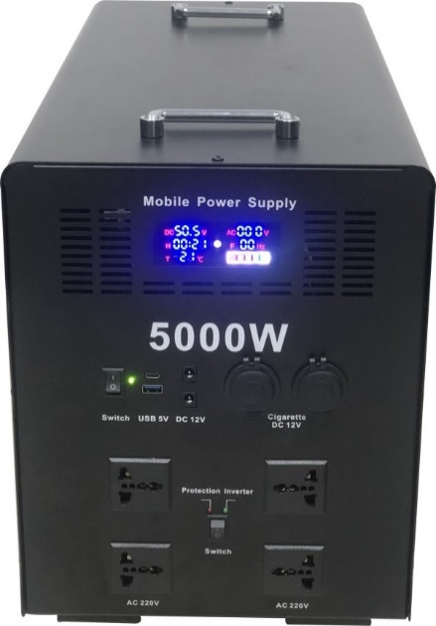

SJ-M-5000

Inverter power: 5000W (pure sine wave, high frequency) peak power: 5500W 48V system

Battery charge: 5000WH

Battery type: lithium iron phosphate battery (overcharge, overdischarge, overtemperature protection), front power off master switch

Ac output: AC220V/50HZ, 3 plug 4 (European plug, British plug, South Africa plug, etc.)

DC output: DC12V/10A*2, car charge 4 (built-in fuse), USB port output: DC5V/3A

LCD display screen: four buttons, master switch, USB, LED, AC220V, battery display, charge icon display, USB output

Display, AC220V start display, fault icon display, charge and discharge fault code display, LED lamp display, AC output power display, transmission

Input power display, fan operation display, Bluetooth switch display, high and low temperature detection display, over-voltage under-voltage alarm, over-current short-circuit alarm

Heat dissipation system: temperature control self-start, one in and one out of the air duct quickly dissipate heat

Charging method: AC220V/5A adapter, solar panel DC18V/100W/5A (optional 3 strings and 3 parallel), full charge time 5-7 hours.

Inverter protection: reverse connection, short circuit, overload, overtemperature 40 °, overvoltage power outage DC58-60V, low voltage power outage DC38-40V, conversion efficiency 90.5%

Applicable scenarios: outdoor activities, household energy storage, farm energy storage, fishing boat electricity

Scope of application: cutting machine 1100W, high pressure water gun 1200W, impact drill 1080W, air pump 800,1500W, kettle 1000W, microwave oven 1300

W, electric casserole 1500W, electric vehicle 1050W, electric oven 1650W, car washing machine 1000 2000W, air conditioning 1260W, electric vehicle

1050W, electric oven 1650W

Shell color: black, white (customizable 500PCS)

Product size: 650*270*330mm

Packing size: 670*330*460mm

Number of boxes: 1 PCS

Gross weight: 55kg net weight: 49 kg